**KIDS-ZONE**

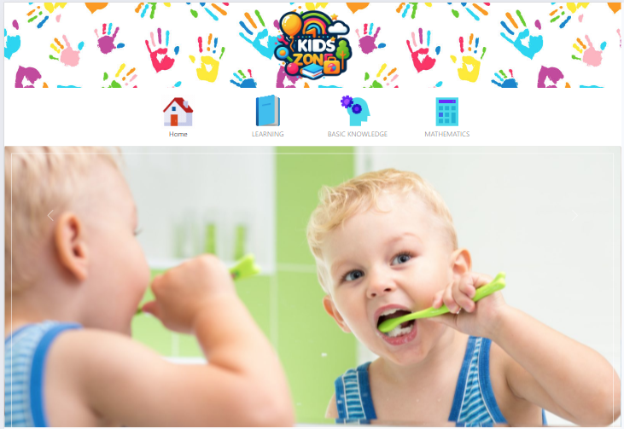

|  |  |  |
| --- | --- | --- |
| **Supervisor** | SIR OWAIS AHMED KHAN | |
| **Batch** | 2306C2 | |
| **Group** | **B** | |
| **Serial No.** | **Enrollment Number** | **Student Name** |
| 1. | Student1519924 | MUHAMMAD DANIYAL SIDDIQUI |
| 2. | Student1519925 | ABDUL MOIZ SIDDIQUI |
| 3. | Student1522820 | HAFIZ HUMAIR ADEEL |
| 4. | Student1519937 | MUHAMMAD AREEB |

# Problem Statement:

The www.kids-Zone website is designed for the Kids (Toddlers) for Learning ABC’s in

more creative way. The website includes the ABC with A for …., B for….

Also it includes some nursery rhymes with images so that child can grasp more

easily. One two three till 100 with and without spellings, some basic calculation of

addition and subtraction. Prayers, Galleries of basic animals, plants, fruits, games

colors, Sunday-Mondays and so on.

# Functional Requirement Specification:

The Web site is to be created based on the following requirements.

1) Home page must be designed by including various interactive images like of a

child say prayer, brushing teeth, drinking milk and so on.

2) Navigation links must be included and must be designed in an interactive way

so as to become more user friendly for the kids.

3) Font sizes must be selected appropriately thinking about the end users.

4) Navigation must be made user friendly.

5) Menus can be included such as :

- ABC.s

- abc.s

- 123….

- Table of 2, 3,4, 5

- Some nursery rhymes with relevant images.

- Basic colors

- Some animals

- Some Vegetables

- Sunday, Monday…

- January, February

- Addition (here allow the end user to enter the value and message must be

prompted whether correct ans or incorrect)

- Subtraction (here allow the end user to enter the value and message must be

prompted whether correct ans or incorrect)

6) Look and feel must be made user friendly.

7) Uniformity and Navigation must be made smooth throughout the website.

**Acknowledgment:**

We are thrilled to embark on the journey of crafting a cutting-edge news platform for DNBC, a leading news agency dedicated to delivering accurate and timely information to its audience. Our team's proficiency in HTML5, JSON, React JS, JavaScript, and dynamic content presentation, coupled with a steadfast commitment to ensuring compatibility across various devices and browsers, assures the creation of an engaging and accessible website. Our aim is to not only simplify the process of accessing news but also to revolutionize the way users interact with information, offering a seamless experience that adapts to modern browsing habits. We eagerly anticipate collaborating with DNBC to transform this vision into reality and provide audiences worldwide with a contemporary, intuitive, and informative news hub.

**Synopsis:**

**Introduction:**

The thirst for learning, upgrading technical skills and applying the concepts in real

life environment at a fast pace is what the industry demands from IT professionals

today. However busy work schedules, far-flung locations, unavailability of convenient

time-slots pose as major barriers when it comes to applying the concepts into

realism. And hence the need to look out for alternative means of implementation in

the form of laddered approach.

**User Interface:**

The above truly pose as constraints especially for our students too! With their busy

schedules, it is indeed difficult for our students to keep up with the genuine and

constant need for integrated application which can be seen live especially so in the

field of IT education where technology can change on the spur of a moment. Well,

technology does come to our rescue at such times!!

**Conclusion:**

Keeping the above in mind and in tune with our constant endeavour to use

Technology in our training model, we at Aptech have thought of revolutionizing the

way our students learn and implement the concepts using tools themselves by

providing a live and synchronous eProject learning environment!

**Navbar:**



There are Four essentials listed here, and you will be redirected to all the pages, which are further classified as:

* **HOME:** Home page is designed by including various interactive images like of a child say prayer, brushing teeth, drinking milk and so on.
* **LEARNING:** It is Further divided:
* Alphabets
* Numbers
* Tables
* Rhymes
* **KNOWLEDGE:** It is Further divided:
* Vegetables
* Fruits
* Animals
* Days
* Months
* Colors
* **MATHEMATICS**: It is Further divided:
* Addition
* Subtraction
* Multiplication

**Footer:**

Our footer embodies connectivity and information accessibility. Stay connected with us across various social media platforms to keep abreast of the latest updates. Explore our diverse new pages— For inquiries, feedback, or collaboration, reach out through the provided contact details. Thank you for choosing KIDS-ZONE as your reliable source of news and information.

© 2024 KIDS ZONE

**Task Sheet Review:**

|  |  |  |  |  |  |  |
| --- | --- | --- | --- | --- | --- | --- |
|  | | **Project Title** | **Date of Preparation of Activity Plan** | | | |
| No. | **Task** |  | Actual | Actual | Name | Status |
| Start date | Days |
| 1 | Navbar | News Reporter | 24/Jan/24 | 1 | Moiz & Daniyal | Complete |
| 2 | Build Home Page | News Reporter | 26/Jan/24 | 3 | Daniyal | Complete |
| 3 | Build Learning Page | News Reporter | 30/Jan/24 | 1 | Moiz | Complete |
| 4 | Build Knowledge Page | News Reporter | 31/Jan/24 | 1 | Daniyal | Complete |
| 5 | Footer | News Reporter | 2/Feb/24 | 2 | Moiz | Complete |
| 6 | Build ABC, 123 and Tables Page | News Reporter | 5/Feb/24 | 2 | Moiz & Daniyal | Complete |
| 7 | Build Fruit and Vegetables Page | News Reporter | 10/Feb/24 | 2 | Moiz & Daniyal | Complete |
| 8 | Build Animal and Rhymes Page | News Reporter | 14/Feb/24 | 2 | Moiz & Daniyal | Complete |
| 9 | Build Days and Month Page | News Reporter | 16/Feb/24 | 2 | Moiz & Daniyal | Complete |
| 10 | Build Color Pages | News Reporter | 17/Feb/24 | 1 | Moiz & Daniyal | Complete |
| 11 | Build Addition, Subtraction and Multiplication Pages | News Reporter | 20/Feb/24 | 4 | Moiz & Daniyal | Complete |